Elton, Gruber, Brown, and Goetzmann
Modern Portfolio Theory and Investment Analysis, 9th Edition
Solutions to Text Problems: Chapter 14

Chapter 14: Problem 1

Given the zero-beta security market line in this problem, the return on the zero-beta portfolio equals 0.04 (4%), the intercept of the line, and the excess return of the market above the zero-beta portfolio’s return (also called the “market risk premium”) equals 0.10 (10%), the slope of the line. The return on the market portfolio must therefore be 0.04 + 0.10 = 0.14, or 14%.

Chapter 14: Problem 2

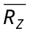 has the same role in the zero-beta model as R_{F} does in the standard model. So, referring back to the answer to Problem 5 in Chapter 13, simply replace R_{F} with to obtain:

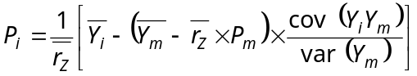

where 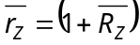.

Chapter 14: Problem 3

As is shown in the text, the post-tax form of the CAPM’s equilibrium pricing equation is:

Rearranging the above equation to isolate δ_{i} we have:

Comparing the above general equation to the specific one given in the problem, we see that 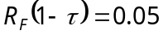, or 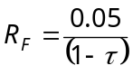, and that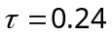. Therefore:

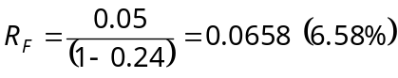

Chapter 14: Problem 4

Since we are given 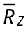 and only one R_{F} , and since > R_{F} , this situation is where there is riskless lending at R_{F} and no riskless borrowing. The efficient frontier will therefore be a ray in expected return-standard deviation space tangent to the minimum-variance curve of risky assets and intersecting the expected return axis at the riskless rate of 3% plus that part of the minimum-variance curve of risky assets to the right of the tangency point. This is depicted in the graph below, where the efficient frontier extends along the ray from R_{F} to the tangent portfolio L, then to the right of L along the curve through the market portfolio M and out toward infinity (assuming unlimited short sales). Note that, unless all investors in the economy choose to lend or invest solely in portfolio L, the market portfolio M will always be on the minimum-variance curve to the right of portfolio L.

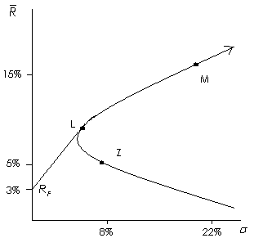

Since both M and Z are on the minimum-variance curve, the entire minimum-variance curve of risky assets can be traced out by using combinations (portfolios) of M and Z. Letting X be the investment weight for the market portfolio, the expected return on any combination portfolio P of M and Z is:

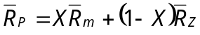 (1)

Recognizing that M and Z are uncorrelated, the standard deviation of any combination portfolio P of M and Z is:

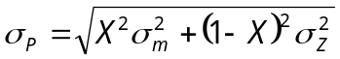 (2)
Substituting the given values for 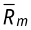 and into equation (1) gives:

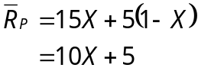 (3)

Substituting the given values for 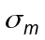 and 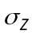 into equation (2) gives:

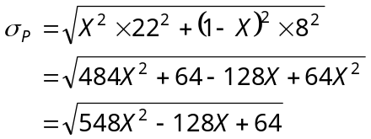 (4)

Using equations (3) and (4) and varying X (the fraction invested in the market portfolio M) gives various coordinates for the minimum-variance curve; some of them are given below:

X 0 0.2 0.4 0.6 0.8 1.0 1.5 2.0

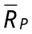 5 7 9 11 13 15 20 25

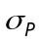 8 7.77 10.02 13.58 17.67 22 33.24 44.72

The zero-beta form of the security market line describes equilibrium beta risk and expected return relationship for all securities and portfolios (including portfolio L) except those combination portfolios composed of the riskless asset and tangent portfolio L along the ray R_{F} - L in the above graph:

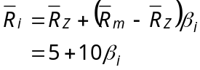

The equilibrium beta risk and expected return relationship for any combination portfolio C composed of the riskless asset and tangent portfolio L along the ray
R_{F} - L in the above graph is described by the following line:

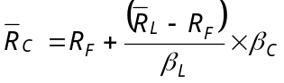

Combining the two lines yields the following graph:

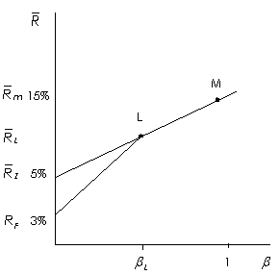

Chapter 14: Problem 5

If the post-tax form of the equilibrium pricing model holds, then:

If the standard CAPM model holds, then:

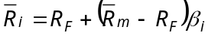

Assume that the post-tax model holds instead of the standard model, and 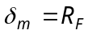.

For a stock with 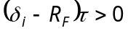, the institution that uses the post-tax model would correctly believe that the stock has a higher expected return than the stock’s return expected by the institution using the standard model. Similarly, for a stock with 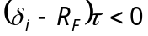, the institution that uses the post-tax model would correctly believe the stock has a lower expected return than the stock’s return expected by the institution using the standard model.

Now consider a specific example using the following data for stocks A and B, the market portfolio and the riskless asset:

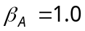; 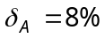; 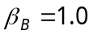; 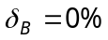; 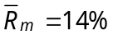; 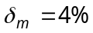; 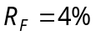; 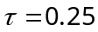

If the post-tax model holds, then the institution using that model would correctly believe that the equilibrium expected returns for the two stocks are:

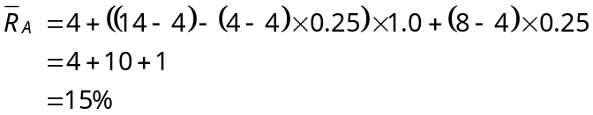

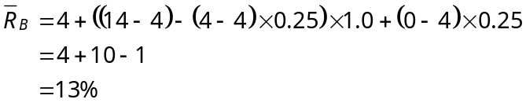

The institution using the standard model would incorrectly believe that the stocks’ equilibrium expected returns are:

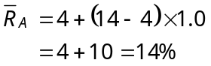

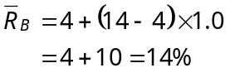

The institution using the post-tax model would tend to buy stock A and sell stock B short. Of course, residual risk puts a limit to the amount of unbalancing the institution would do. But by some unbalancing, the institution earns an excess return.

The institution using the standard model would be indifferent between the two stocks. However, by buying stock B, the institution loses excess return.

Chapter 14: Problem 6

Using Ross’s APT model, we can create an arbitrage portfolio as follows:

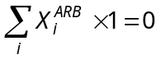 (1)

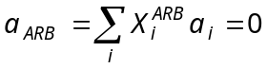 (2)

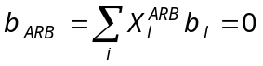 (3)

Since the above portfolio has zero net investment and zero risk with respect to the given two-factor model, by the force of arbitrage its expected return must also be zero:

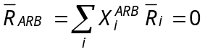 (4)

From a theorem of linear algebra, since the above orthogonality conditions (1), (2) and (3) with respect to the 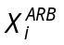 result in orthogonality condition (4) with respect to the , 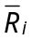 can be expressed as a linear combination of 1, a_{i} and b_{i}:

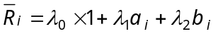 (5)

We can create a zero-risk investment portfolio as follows:

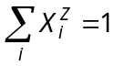

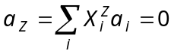

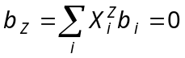

Substituting the above equations into equation (5) gives:

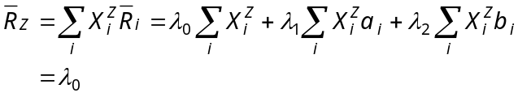

We can create a strictly market-risk investment portfolio as follows:

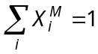

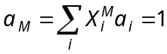

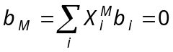

Substituting the above equations into equation (5) gives:

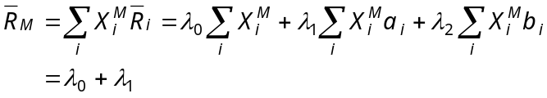
or
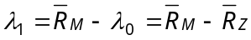

We can create a strictly interest rate-risk investment portfolio as follows:

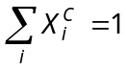

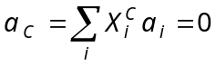

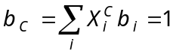

Substituting the above equations into equation (5) gives:

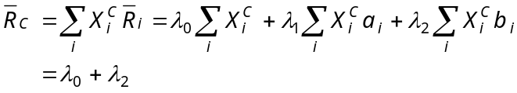
or
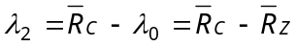

Substituting the derived values for λ₀, λ₁ and λ₂ into equation (5), we have:

Chapter 14: Problem 7

In the graph below, the efficient frontier with riskless lending but no riskless borrowing is the ray extending from R_{F} to the tangent portfolio L and then along the minimum-variance curve through the market portfolio M and out toward infinity (assuming unlimited short sales). All investors who wish to lend will hold tangent portfolio L in some combination with the riskless asset, since no other portfolio offers a higher slope. Furthermore, unless all investors lend or invest solely in portfolio L, the market portfolio M will be along the minimum-variance curve to the right of portfolio L, since the market portfolio is a wealth-weighted average of all the efficient risky-asset portfolios held by investors, and no rational investor would hold a risky-asset portfolio along the curve to the left of L.

The expected return on a zero-beta asset is the intercept of a line tangent to the market portfolio, and the zero-beta portfolio on the minimum-variance frontier must be below the global minimum variance portfolio of risky assets by the geometry of the graph. Furthermore, by the geometry of the graph, since the risk-free lending rate is the intercept of the line tangent to portfolio L, and since L is to the left of M on the minimum-variance curve, the risk-free lending rate must be below the expected return on a zero-beta asset.

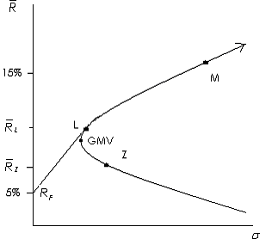

The zero-beta security market line is the line in the graph below extend from the expected return on a zero-beta asset through the market portfolio and out toward infinity (assuming unlimited short sales). The expected return-beta relationships of all risky securities risky-asset portfolios (including the market portfolio M and portfolio L) are described by that line. The other line from the risk-free lending rate to portfolio L only describes the expected return-beta relationships of combination portfolios of the risk-free asset and portfolio L; those combination portfolios are not described by the zero-beta security market line.

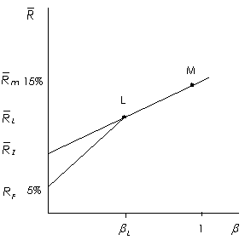

Chapter 14: Problem 8

Assume the same situation as in Problem 5. The investor who believes in the standard (pre-tax) CAPM expects a return of 14% on either security. You expect a return before taxes of 15% on stock A and 13% on stock B. If your tax factor was below the aggregate tax factor (τ lower than 0.25) then you should buy stock B from the other investor and sell that investor stock A. The fact that this will lead to higher after-tax cash flows for you is straightforward.

Chapter 14: Problem 9

This problem can be answered directly by using the equation developed for non-marketable assets. The equation also holds for deleted assets, with the subscript H now standing for those assets that were left out:

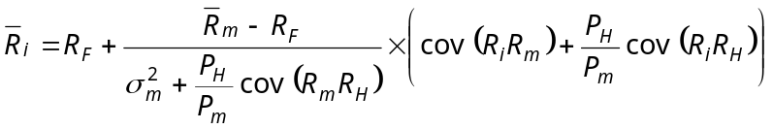

The effect of leaving out bonds depends on two factors:

1.) Whether or not the returns on the aggregate of all bonds are negatively or positively correlated with the returns on the aggregate of all stocks;

2.) The correlation between the returns on a particular stock and the returns on the aggregate of all bonds.

From the above equation, if returns on stocks and bonds are generally positively correlated (as empirical evidence shows), then the denominator in the second term of the equation will tend to lower the expected return on any stock. If the return on a particular stock is negatively correlated with bonds, that will further lower the stock’s expected return. However, if the stock is positively correlated with bonds, this will offset the effect of positive correlation between all stocks and bonds and may actually result in a higher expected return for the stock.

